Create a blank file - myfile

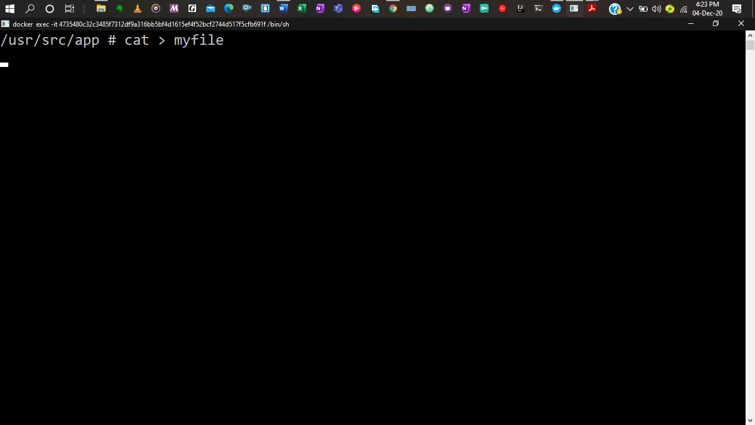

Open file – myfile and add name, address, emailed, phoneno and blood group.

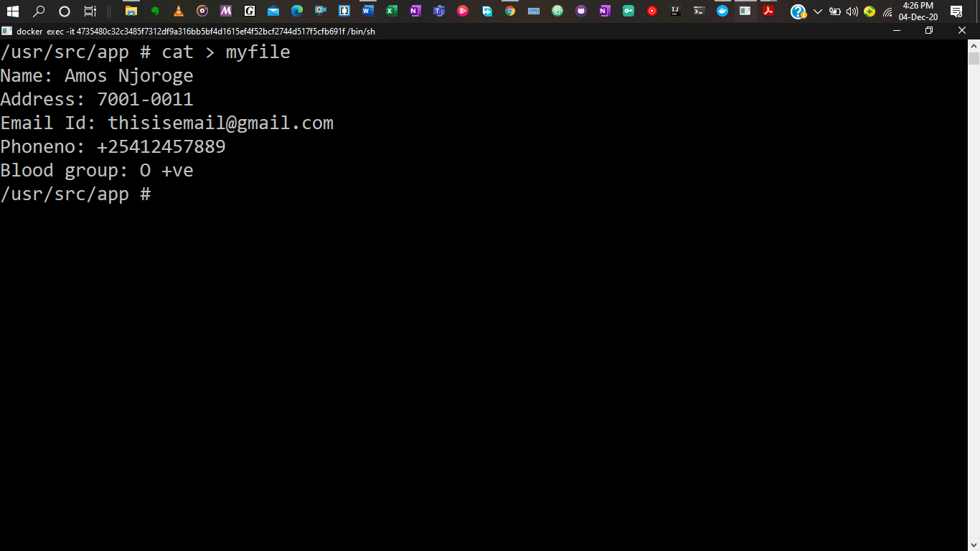

Build one single expression to see the line with your name and group in myfile.

